**Chapter 12 Assignments**

**You Do It:**

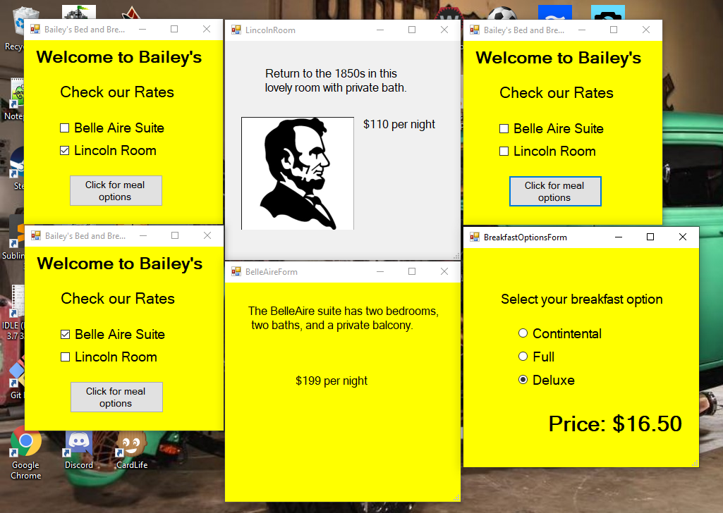

**Chapter Review Questions:**

1. D
2. A
3. A
4. C
5. A
6. C
7. D
8. A
9. D
10. B
11. B
12. A
13. B
14. A
15. B
16. B
17. D
18. A
19. A
20. C

**Programming Exercises:**